

**Assignment**

**Of**

**System Integeration And Architecture**

**Submitted To:**

**Sir.Muhammad Ali Memon**

**Professor Dept:**

**Information Technology**

**Submitted By:**

**Mubashir Ali S/O**

**Mansoor Ali**

**(2k20/ITE/73)Group(A)**

**1.Singleton Pattern:**

In Object-oriented programming, a singleton class is a category that could have simplest one item (an instance of the magnificence) at a time. After the first time, if we try to instantiate the Singleton elegance, the new variable additionally points to the primary instance created. So whatever adjustments we do to any variable inside the class via any example, affects the variable of the unmarried example created and is visible if we get entry to that variable thru any variable of that class kind described.

take into account the important thing points at the same time as defining class as a singleton elegance that is at the same time as designing a singleton class:

1.Make a constructor private.

2.Write a static technique that has the return kind item of

This singleton elegance. right here, the concept of Lazy initialization is used to jot down this static method.

**Motive of Singleton Magnificence:**

The primary purpose of a Singleton class is to limit the restrict of the variety of object advent to best one. This regularly ensures that there's get entry to manage to assets, as an example, socket or database connection.

The memory area wastage does no longer occur with the use of the singleton elegance as it restricts the instance creation. because the item advent will take region handiest once rather than growing it every time a new request is made.

We can use this single item repeatedly as according to the requirements. that is the purpose why the multi-threaded and database packages primarily employ the Singleton pattern in Java for caching, logging, thread pooling, configuration settings, and lots extra.

As an instance, there is a license with us, and we've got simplest one database connection or assume if our JDBC driving force does not allow us to do multi-threading, then Singleton magnificence comes into the photograph and makes certain that at a time, best a unmarried connection or a single thread can get right of entry to the connection.

a way to layout/Create a Singleton magnificence in Java?

To create a singleton class, we must observe the steps, given beneath:

1. Make sure that handiest one example of the magnificence exists.

2. Offer international get admission to to that instance by way of maintaining all constructors of the class to be personal.

Offering a static approach that returns a reference to the instance.

The lazy initialization idea is used to put in writing the static strategies.

The instance is saved as a private static variable.

Instance of singleton training is Runtime class, action Servlet, service Locator. personal constructors and manufacturing facility strategies also are an instance of the singleton elegance.

Distinction among ordinary class and Singleton class we will distinguish a Singleton elegance from the usual training with appreciate to the procedure of instantiating the object of the magnificence. To instantiate a ordinary elegance, we use a java constructor. however, to instantiate a singleton class, we use the getInstance() method.

The opposite difference is that a regular class vanishes on the stop of the lifecycle of the utility even as the singleton magnificence does now not spoil with the completion of an utility.

**Sorts Of Singleton Elegance Pattern:**

There are styles of singleton design sample, which might be:

**Early Instantiation:**

The object advent takes location at the load time.

**Lazy Instantiation:**

The item creation is achieved in step with the requirement.

**Implementation:**

let us quick how the singleton class varies from the normal class in java. here the difference is in terms of instantiation as for normal class we use constructor, whereas for singleton magnificence we use getInstance() technique which we are able to be peeking out in instance 1 as depicted under. In standard, for you to keep away from confusion, we may use the magnificence call as approach name at the same time as defining this approach in order to be as depicted in instance 2 underneath as follows.

**Source Code:**

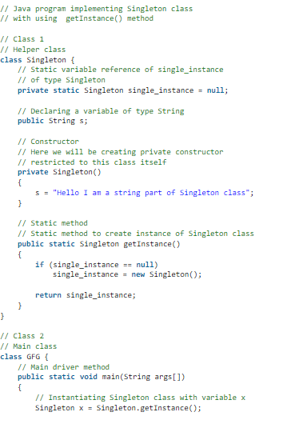

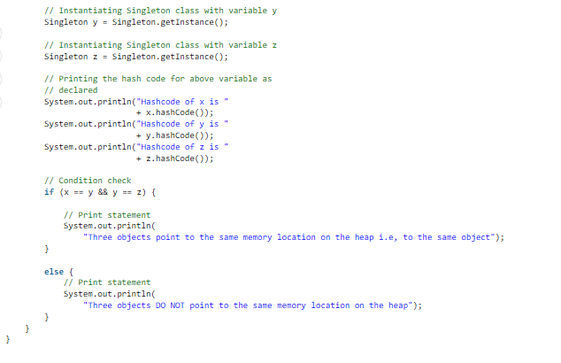

**Output:**

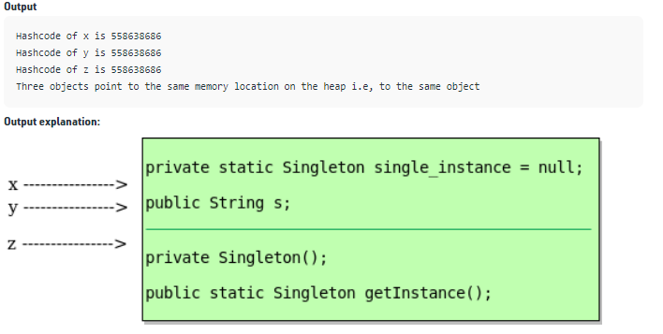

**2.Adapter Pattern:**

This sample is straightforward to understand as the actual international is full of adapters.   as an instance don't forget a USB to Ethernet adapter. We want this when we've an Ethernet interface on one end and USB on the alternative. considering they're incompatible with each other. we use an adapter that converts one to different. this situation is quite analogous to object oriented Adapters. In design, adapters are used when we've got a category (purchaser) anticipating some sort of item and we've an object (Adaptee) imparting the same capabilities however exposing a special interface.

to use an adapter:

1.The consumer makes a request to the adapter through calling a method on it the use of the target interface.

2.The adapter translates that request on the adaptee the use of the adaptee interface.

3.purchaser acquire the consequences of the call and is blind to adapter’s presence.

**Definition:**

The adapter pattern convert the interface of a category into any other interface clients assume. Adapter shall we training paintings together that couldn’t in any other case because of incompatible interfaces.

**Class Diagram:**  
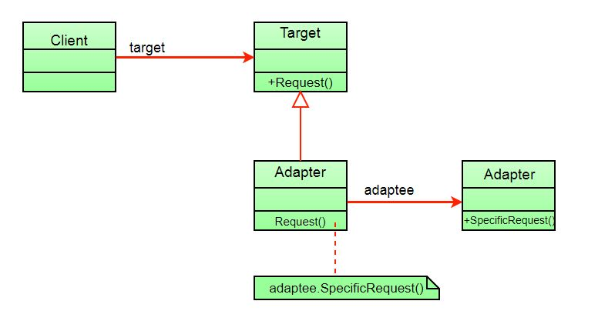

The purchaser sees only the goal interface and now not the adapter. The adapter implements the goal interface. Adapter delegates all requests to Adaptee.

**Instance:**

Assume you have a chook class with fly() , and makeSound() strategies.

And additionally a ToyDuck magnificence with squeak() method. allow’s count on which you are short on ToyDuck objects and also you would really like to apply hen items of their area. Birds have a few comparable capability but enforce a special interface, so we will’t use them immediately. So we are able to use adapter sample. right here our consumer might be ToyDuck and adaptee would be chook.

**Below Is Java Implementation:**

**Source Code:**

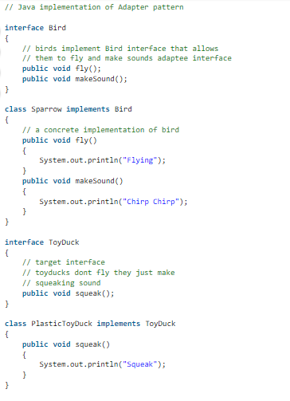

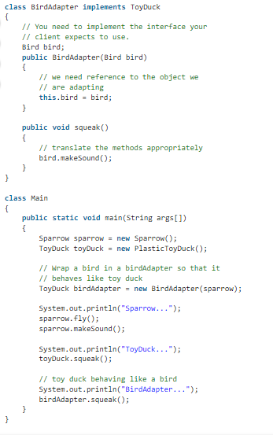

**Output:**

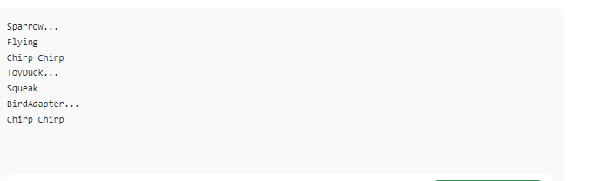

**3.Bridge layout Pattern:**

The Bridge layout pattern permits you to split the abstraction from the implementation. it is a structural layout sample.

There are 2 parts in Bridge design pattern :

1.Abstraction

2.Implementation

This is a layout mechanism that encapsulates an implementation magnificence interior of an interface class.

The bridge sample permits the Abstraction and the Implementation to be evolved independently and the client code can access simplest the

Abstraction element without being worried approximately the Implementation element.

The abstraction is an interface or summary class and the implementer is also an interface or abstract class.

The abstraction consists of a reference to the implementer. youngsters of the abstraction are called refined abstractions, and kids of the implementer are concrete implementers. on account that we can change the connection with the implementer in the abstraction, we are able to trade the abstraction’s implementer at run-time. modifications to the implementer do no longer affect customer code.

It increases the loose coupling among class abstraction and it’s implementation.

**UML Diagram of Bridge Design Pattern:** 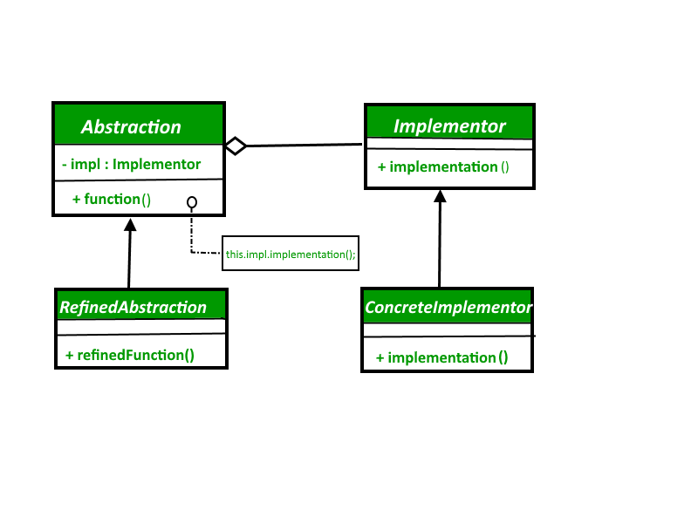

**Factors Of Bridge Layout Pattern:**

**Abstraction** – middle of the bridge design pattern and defines the crux. consists of a connection with the implementer.

**Refined Abstraction** – Extends the abstraction takes the finer detail one level underneath. Hides the finer elements from implementors.

**Implementer** – It defines the interface for implementation lessons. This interface does no longer want to correspond without delay to the abstraction interface and can be very extraordinary. Abstraction imp affords an implementation in terms of operations provided by means of the Implementer interface.

**Concrete Implementation** – Implements the above implementer by using supplying the concrete implementation.

**Source Code:**

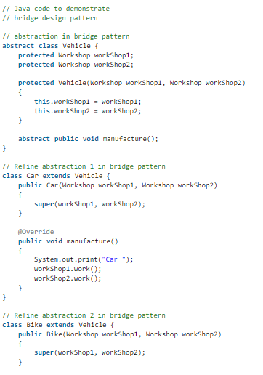

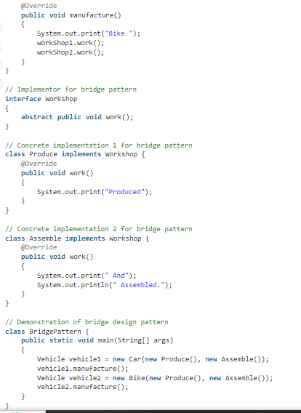

**Output:**

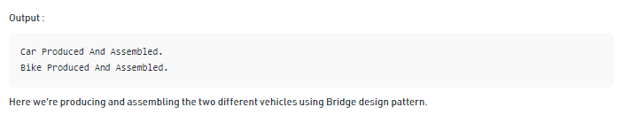

**4.Visiter Design Sample:**

Traveler layout pattern is one of the behavioral layout patterns. it's far used while we should carry out an operation on a set of similar form of objects. With the assist of tourist pattern, we are able to flow the operational good judgment from the gadgets to some other magnificence.

The vacationer sample consists of two parts:

A technique known as go to() that is carried out by means of the visitor and is called for each element within the records structure visitable training providing be given() strategies that be given a visitor.

**UML Diagram Visitor Design Pattern**

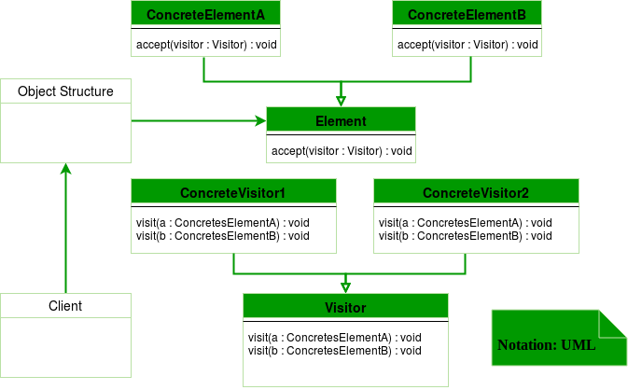

**Visiter Design components:**

**Patron** : The customer class is a customer of the training of the vacationer design pattern. It has get entry to to the statistics shape items and can coach them to just accept a tourist to carry out the ideal processing.

**Vacationer** : that is an interface or an abstract class used to claim the go to operations for all of the kinds of visitable training.

**Concrete Visitor** : For every type of traveler all the visit methods, declared in summary traveller, ought to be implemented. every traveller might be accountable for one of a kind operations.

**Visitable** : that is an interface which declares the receive operation. this is the entry factor which allows an item to be “visited” by way of the visitor item.

**Concrete Visitable** : those training enforce the Visitable interface or class and defines the take delivery of operation. The tourist item is surpassed to this item the use of the accept operation.

**Source Code:**

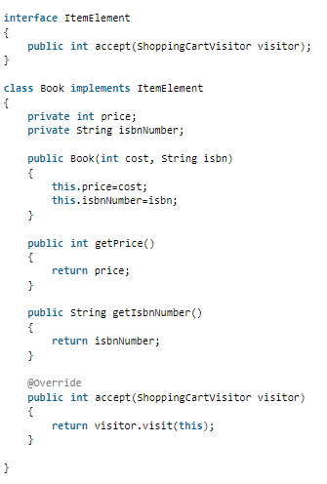

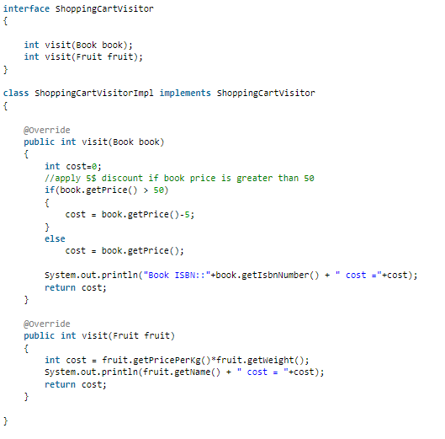

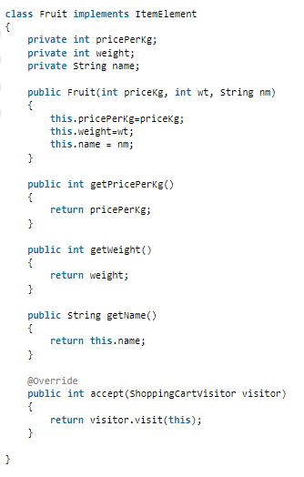



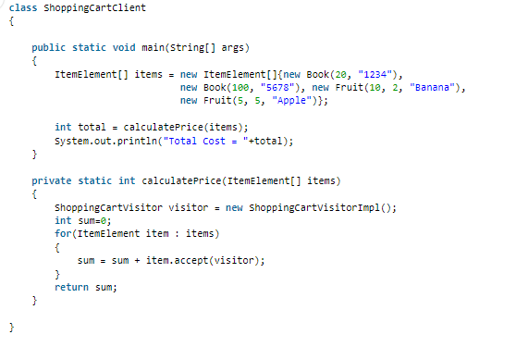

**Output:**

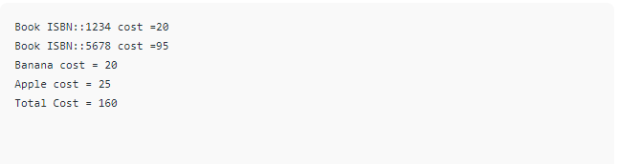

***The End***